An Efficient Gesture Based Control Of Operating System

Ms. M.S. Sruthi
Department of computer science and engineering
Sri Krishna College Of Technology
Kerala, India
sruthims041@gmail.com

V. Arun
Department of computer science and engineering
Sri Krishna College Of Technology
Tamilnadue, India
arunstark85@gmail.com
E. Jithin suresh
Department of computer science and engineering
Sri Krishna College Of Technology
Kerala, India
jithinsuresh7060@gmail.com
E. Jijin suresh
Department of computer science and engineering
Sri Krishna College Of Technology
Kerala, India
jijinsuresh6@gmail.com

The proposed system provides a path for humans to interact with the operating system very efficiently. Even though the mechanical mouse is considered useful it also contains some cons where it does not provide long time support, requires external connections like wires, runs out of power, and changes batteries frequently, the proposed system does not have any of these problems. It only requires an inbuilt camera or an external camera feed as input. this project promotes human-computer interaction where cursor movement and different mouse events are controlled using hand gestures shown in the real-time camera

INTRODUCTION
Gesture-based conversation between humans has been a habitat the conversation signs like thumbs up, shaking hands, and more from this we can understand that gesture-based conversation are the easiest way to communicate and interact with each other even deaf people can understand the alphabet shown using hand sign and communicate accordingly. In this proposed system we will get deep inside gesture-based control of the operating system. The operating system is mainly controlled using a mechanical mouse so the proposed system will control the cursor of the operating system using hand gestures events like right click, left click drag and drop, and many other events are controlled using hand gestures in this project. few gadgets like the mechanical mouse and wireless mouse have their disadvantages so if the user can’t afford a mouse are tired of using a mechanical mouse can start to control the mouse through hand gestures shown in the inbuilt or external camera. To build the proposed system python programming language is used to empower the gesture-based control of the operating system. In python, there are some packages built for satisfying our requirements they are mediapipe, autogui, and autopy. mediapipe is the main package that reads and recognizes human hands and other packages like autopy and autogui are used for performing some actions like right or left click, drag and drop function, and many other operations are done by the cursor in the operating system. The gesture-based control of the cursor in the operating system is expected to control the operating system even more interactively and comfortably than the mechanical mouse. furthermore, the proposed system could assist the operating system where the users could interact using the hand gesture shown in the inbuilt or external camera without using any other special gadgets. Now a day video conference is used to share information with large people for this reason nowadays laptops are available with an inbuilt camera. as the proposed system's main pathway to get input is through the camera. The user doesn't need to spend money on any other gadgets so in this way are project is also cost-effective. the process of controlling an operating system or a machine using hand gestures is a very interesting and effective approach in HCI (Human-computer interaction). Hand gesture recognition technology is also popular in sign language recognition.

METHODOLOGY
According to the research done, we humans used to communicate through writing, facial expression, and even through hand signs. Our ancestors have done some carving in the stone Those carvings are not only in letters but also represented pictorially to make other people understand clearly and quickly. Even during this current generation, people use hand signs to make their conversation quick with others. Conversations between deaf people are done using hand gestures which we call sign language. The hand gesture used for deaf people represents the alphabet in hand gesture format. So from here, we came to know that sign language is understood well among people everywhere. People having different native languages can make an understanding between them using hand signs. So if we use hand gestures to control the operating systems it makes the conversation between humans and the system more interactive. In this project, we are mainly concentrating on how to control the operating system using hand gestures. Mainly the operating system is controlled using the cursor on the desktop. the cursor act as the main path to control the operating system normally we use a mechanical mouse or a trackpad to control it but it has its disadvantage like not being long-lasting needs wire and cables to connect with the system, in case of Bluetooth connection we must frequently change the battery of the Bluetooth mouse or trackpad. So the software I create will control the cursor of the operating system. To make this solution we chose python language because it is an easy and understandable language that is also currently emerging in recent years and also there are many advantages while using python packages. The packages used in this project are mediapipe, OpenCV, autopy, and pyautogui. The workflow of the software created is explained and depicted in the below flow chart.
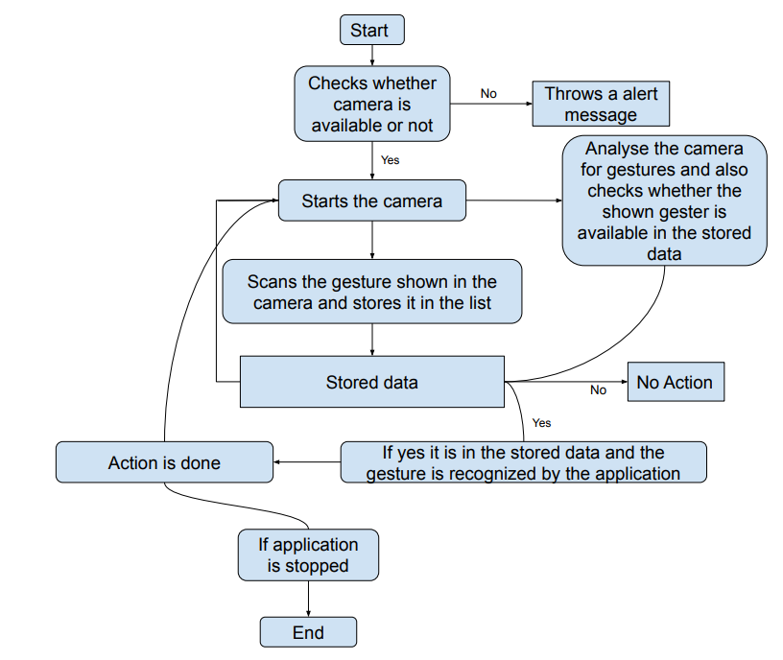
Figure 1: Flow chart of proposed system
The proposed virtual mouse system is based on the frames that have been captured by the integrated camera in a laptop or PC. At first the program starts running the camera to capture images. In the next step the program starts to detect hand gestures, the program starts to detect which finger is shown up using the tip ID of the respective finger that we found using the MediaPipe python library. Then it starts to recognize the gesture shown and performs function according to the shown gesture. For ex: if the index finger tip ID is 1 and the middle finger with tip ID 2 is up then the cursor of the operating system starts to move around the operating system. This operation is done using the python library named AutoPy. Other right and left click options are done AutoGui library in python.
The project's language of choice is Python. Apart from the fact that it is simple to use and simple to grasp, we chose to utilise Python since it is frequently used for ML and AI projects. Python also has a number of AI-based packages, like mediapipe, opencv, and others. Python is utilised since no comparable packages exist for other programming languages. It is an open-source platform for computer vision algorithms that use data like video and audio. In order to make the application function, mediapipe is utilised, and mediapipe acts as the main algorithm to deal with the data acquired using the camera. Mediapipe is used to work with the data collected from the built-in camera in the systems. The data gathered by the system's built-in camera was used by mediapipe to operate. It primarily uses the information gathered from the built-in camera to do image processing. Data must be provided in the application as mediapipe requests it. With the aid of the opencv library, the data is extracted from the video. With opencv, we may manipulate the pixel values directly, access picture characteristics, choose a specific region from an image, split images, and more. Hence, in order to pick a region to focus on, gather data from it, and feed it information, we need information from our hands, specifically the locations of each finger and other parts of our hands. It is a Python GUI automation library. It contains options for managing keyboard and mouse functionality. Additionally, it does other tasks like alert display, colour detection, and more. But operating the mouse is our primary necessity. We can therefore obtain the mouse's functionality using autopy, set gesture values to it, and use it. For instance, if a user does a right click, the user's input gesture will be assigned to that functionality in accordance, and if the user repeats that gesture, the assigned functionality is performed. Camera is utilized for image procesing, the camera will continuously capture image in order for the program to process the image and recognize the hand gesture shown in the image.
RESULT
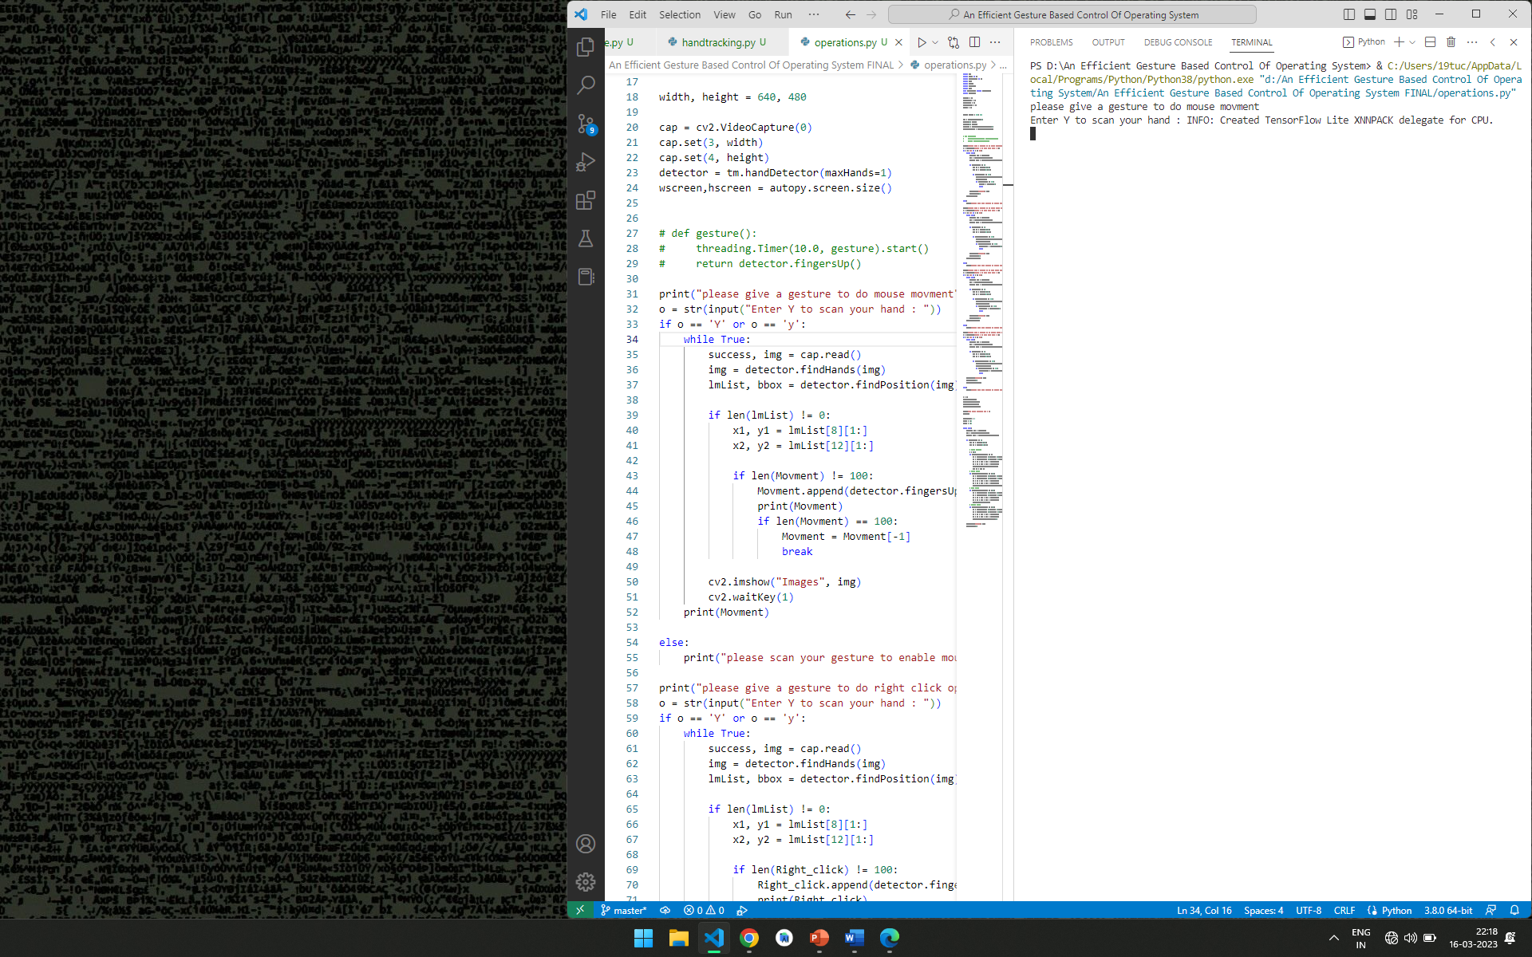
At first, we start to run our application. when the application starts, it will start to ask input for the mouse features in the bellow image it asks gesture input for mouse movement.
Figure 2: gesture input console image
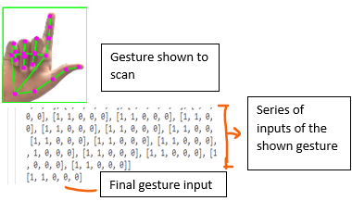
So the user can type y(yes) when he is ready and start scanning his gesture in front of the camera the application starts to scan, recognize the hands gives some series outputs and take a mean of the output and the application sets that gesture for that mouse operation in the below image it shows a series of output and its final result gesture too.

Figure 3: Gesture scanned and determined the input
gesture shown are scanned and converted into list which has 1’s and 0’s in it. And this list is stored in a group of lists. Now these lists of gesture input are iterated and each gesture in the list is assigned to the operations of the mouse like right click, left click, drag and drop operations.
Figure 4: All gestures grouped into 2d list
So According to the above results the application will iterate through this inputs and the application will start to assign this list of gesture according to the mouse operations. The shown gesture for the above results is explained in the below images (Figure 5,6,7,8).
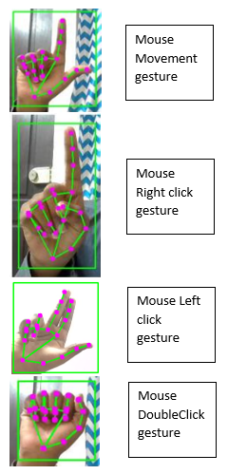
Figure 5: Gesture given by a user to the application
In the above image the gesture is not set in the application it is set by the user dynamically. This gesture is set to the operation to move the cursor over the window.
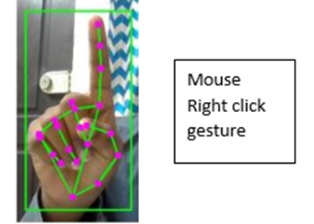
Figure 6: Mouse right click event gesture
In the above image this gesture is set for right click operation.
Figure 7: Mouse left click event gesture
In the above image the gesture set to the left click operation of the mouse.
Figure 8: double click event gesture
in the figure 8 the double click event gesture input is given by the user and the application sets that gesture to that operation of the gesture.
In this application the user will be notified that for which operation the user is giving input so he/she doesn’t need to get confused while giving input to the application the notification is shown in the bellow image.
Figure 9: message that mentions about for which operation we are going to set a gesture
According to the above image this is how the user will be notified about which operation he is going to give input.

ACKNOWLEDGEMENT
We would thank our institution and our faculty guide for extending their fullest cooperation and thankful guidance in completing the project work.

REFERENCE

- Tsai, T. H., Huang, C. C., & Zhang, K. L. (2015, June). Embedded virtual mouse system by using hand gesture recognition. In 2015 IEEE International Conference on Consumer Electronics-Taiwan (pp. 352353). IEEE.
- Farooq, J., & Ali, M. B. (2014, April). Real time hand gesture recognition for computer interaction. In 2014 International Conference on Robotics and Emerging Allied Technologies in Engineering (iCREATE) (pp. 73-77). IEEE.
- Rautaray, S. S. (2012). Real time hand gesture recognition system for dynamic applications. International Journal of ubicomp (IJU), 3(1).
- Shibly, K. H., Dey, S. K., Islam, M. A., & Showrav, S. I. (2019, May). Design and development of hand gesture based virtual mouse. In 2019 1st International Conference on Advances in Science, Engineering and Robotics Technology (ICASERT) (pp. 1-5). IEEE.
- Rautaray, S. S., & Agrawal, A. (2011, December). Interaction with virtual game through hand gesture recognition. In 2011 International Conference on Multimedia, Signal Processing and Communication Technologies (pp. 244247). IEEE.
- Aksaç, A., Öztürk, O., & Özyer, T. (2011, December). Real-time multiobjective hand posture/gesture recognition by using distance classifiers and finite state machine for virtual mouse operations. In 2011 7th International Conference on Electrical and Electronics Engineering (ELECO) (pp. II-457). IEEE.
- Tsai, T. H., Huang, C. C., & Zhang, K. L. (2020). Design of hand gesture recognition system for human-computer interaction. Multimedia tools and applications, 79(9), 5989-6007.
- Hu, C., Liang, L., Ma, S., & Lu, H. (2000, October). Virtual Mouse—inputting device by hand gesture tracking and recognition. In International Conference on Multimodal Interfaces (pp. 88-95). Springer, Berlin, Heidelberg.
- Shahria MT, Sunny MS, Zarif MI, Ahamed SI, Rahman MH. Mapping and Localization in 3D Space for Vision-based Robot Manipulation
- Shriram S, Nagaraj B, Jaya J, Shankar S, Ajay P. Deep learning-based real-time AI virtual mouse system using computer vision to avoid COVID-19 spread. Journal of healthcare engineering. 2021 Oct 25;2021.

